EW 1 LAB 7

Rhea Bagchi 2023102023

Snigdha stp 2023102036

Name of the Experiment: Android-Arduino Integration

Aim:

1. Controlling LED on Arduino uno with App developed in MIT APP Inventor using Bluetooth module
2. Reading values from sensor connected to Arduino uno and display them on the Android App developed in MIT APP Inventor using Bluetooth module.

Components required:

1. Computer with internet access
2. Android smartphone or tablet
3. Arduino
4. HC-05 Bluetooth module
5. Account of MIT app inventor in the device
6. LED, breadboard, wires.

Procedure:

Make arduino connections: 10- Rx , 11 – Tx, ledpin -8, pingpin – 13, echopin – 12.

- Write the code to use sensor on arduino IDE.

- Use HC-05 bluetooth module to upload code to MIT app inventor.

- Once connected, use the ON\OFF switches, and place objects in front of sensor.

Controlling LED on Arduino uno with MIT app inventor:

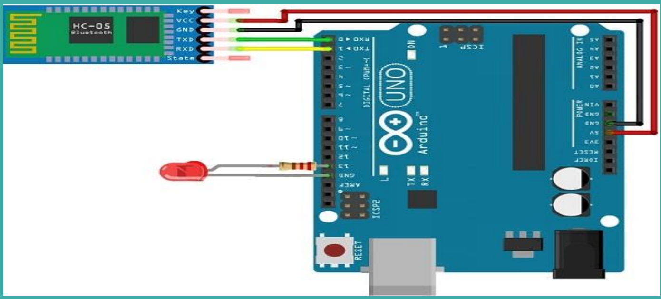

Arduino code for the experiment:

#include SoftwareSerial mySerial(10,11); // 10- Rx , 11 - Tx

int ledpin=13;

int Data;

void setup()

{

mySerial.begin(9600);

pinMode(ledpin,OUTPUT);

}

void loop() {

if (mySerial.available() )

{

Data=mySerial.read();

if(Data=='1')

{ digitalWrite(ledpin,HIGH);

mySerial.println("LED On! ");

}

else if (Data=='0')

{ digitalWrite(ledpin,LOW);

mySerial.println("LED Off! ");

}

}

}

Observations:

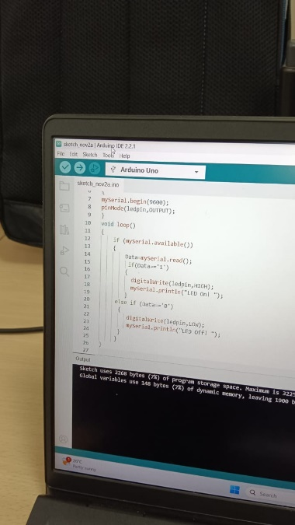

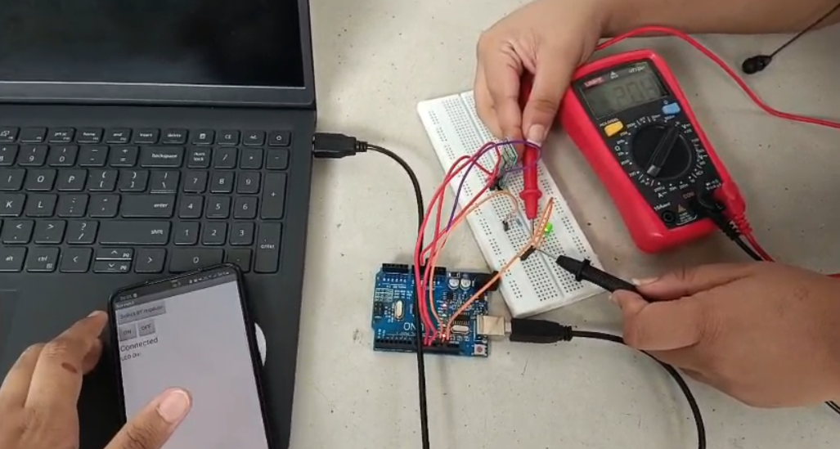

Read values from sensor connected to Arduino uno and display them on the Android App developed in MIT APP Inventor using Bluetooth module:

Arduino code for the experiment:

#include <SoftwareSerial.h>

SoftwareSerial mySerial(0, 1); // 10- Rx , 11 - Tx

int ledpin = 8 ;

int Data, k = 0;

const int pingPin = 13; // Trigger Pin of Ultrasonic Sensor

const int echoPin = 12; // Echo Pin of Ultrasonic Sensor

float duration, cm,distance_cm;

void setup() {

mySerial.begin(9600);

pinMode(ledpin, OUTPUT);

pinMode(pingPin, OUTPUT);

pinMode(echoPin, INPUT);

}

void loop() {

if (mySerial.available()) {

Data = mySerial.read();

if (Data == '1') {

digitalWrite(ledpin, HIGH);

digitalWrite(pingPin, HIGH);

delayMicroseconds(10);

digitalWrite(pingPin, LOW);

duration = pulseIn(echoPin, HIGH);

// cm = microsecondsToCentimeters(duration);

distance_cm = 0.017 * duration;

mySerial.print("distance: ");

mySerial.print(distance_cm);

mySerial.println(" cm");

delay(200);

} else if (Data == '0') {

digitalWrite(ledpin, LOW);

}

}

}

Observations:

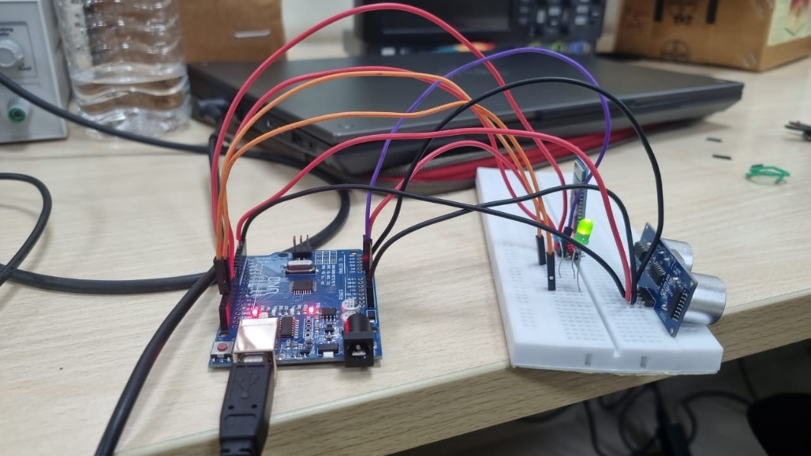

Conclusion:

- Sensor with HC-05 bluetooth connector and MIT app inventor can be used to find displacement of object from sensor.